**MARS Bottler Billing**

Processes Bottler Billing data received from MARS via Synapse. Data is validated and submitted to SAP CI for Invoicing.

**Processing Steps:**

1. Synapse places files containing billing records daily on the NFS share available under /naouteradatanfs/outbound.
2. CM picks up those files via the workflow TCCC_MARS.WFL_MARSBilling_Batch.
3. The files are validated for a non-zero billing amount and to make sure there is a business partner (BP) specified for each record.  
   All records (known as “UDRs” in CM parlance,) including those found invalid, are forwarded via a ‘Workflow Bridge’ to a real-time CM workflow, TCCC_MARS.WFL_MARSBilling_RT.
4. The workflow WFL_MARSBilling_RT checks whether each incoming record is marked as valid or invalid;  
   - Invalid records are only forwarded for reporting purposes.  
   - For each valid record, an SAP Billable Item (BIT) is created and forwarded to SAP Convergent Invoicing (CI) using a Web Service request.  
   - CI returns each record, indicating whether it was successfully processed or not. Unsuccessful records are written to a file for later reprocessing.  
   Successful records are dropped as no further processing is needed.  
    **NOTE:** All records and responses are logged to a database table for troubleshooting purposes, but this table is not for business use.
5. Records that was not submitted successfully are reprocessed, that is, submitted to CI again once daily.
6. Reports are generated and emailed each weekday. The reports contain all failed records, whether they were invalid or, for whatever reason, could not be successfully processed by CI.

**Workflows and Workflow Groups**

|  |  |  |
| --- | --- | --- |
| **Workflow Group** | **Workflow** | **Scheduling** |
| WFG_MARSBillingBatch | TCCC_MARS.WFL_MARSBilling_Batch | 0 – 7am UTC / 5 min. |
| WFG_MARSBillingBatchReprocess | TCCC_MARS.WFL_MARSBilling_Batch | 12:05am UTC Weekdays |
| WFG_MARSBillingRT | TCCC_MARS.WFL_MARSBilling_RT |  |
| WFG_Reporting | TCCC_MARS.WFL_GenReconcReport | 12:03pm Weekdays |
|  | TCCC_MARS.WFL_GetS4Reports |  |
|  | TCCC_MARS.WFL_MergeReports |  |
|  | TCCC_MARS.WFL_MailReports |  |

**File System Locations**

Below is a list of locations in the filesystem used by CM for receiving and processing Bottler Billing records.

|  |  |
| --- | --- |
| **PATH** | **DESCRIPTION** |
| /naouteradatanfs/outbound | Input Files uploaded by Synapse |
| /usr/sap/interfaces/MZP/MARS/Recycling | Files containing records to be reprocessed |
| /usr/sap/interfaces/MZP/MARS/Reports | Reports working directory |
| /usr/sap/interfaces/MZP/MARS/IWF | Internal Inter Workflow working directory |

**Utility tools / scripts.**

1. Shell script, /usr/sap/interfaces/MZP/Scripts/mailMars.sh. Used to mail reconciliation reports.  
   This script is executed by the workflow TCCC_MARS.WFL_MailReports.

**External References**

The workflows get their configuration from an external reference:  
TCCC_MARS.PRF_ExtRef_MARS

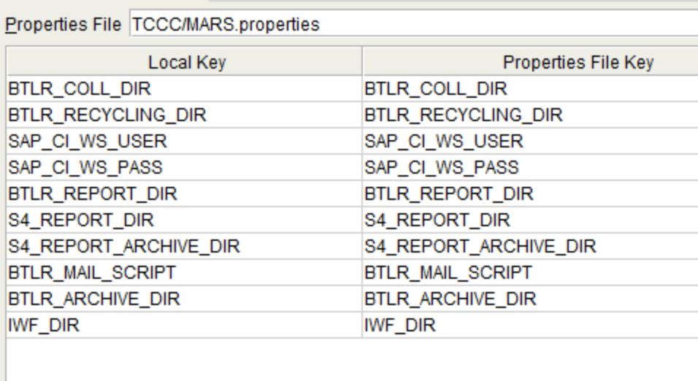

|  |  |
| --- | --- |
| **Parameter** | **Description** |
| BTLR_COLL_DIR | Collection directory for files from Synapse |
| BTLR_RECYCLING_DIR | Location for files to be reprocessed |
| SAP_CI_WS_ADDRESS | URL for the CI Web Service |
| SAP_CI_WS_USER | Username for CI Web Service |
| SAP_CI_WS_PASS | Password for CI Web Service |
| SAP_CLIENT_ID | Client ID for the Convergent Invoicing instance. |
| BTLR_REPORT_DIR | Working directory for reports |
| S4_REPORT_DIR | Location for reports from S4 / CI |
| S4_REPORT_ARCHIVE_DIR | Where to archive CI reports after collection |
| BTLR_MAIL_SCRIPT | Path to shell script for emailing reports |
| BTLR_ARCHIVE_DAYS | How many days to keep archived input files from Synapse |
| BTLR_ARCHIVE_DIR | Location to archive input files from Synapse |
| IWF_DIR | Inter-workflow working directory |

**UDRs**

**BottlerBlgRec**

This UDR is defined by the format of the billing records received from Synapse. It’s decoded into a UDR by a decoder defined in the Ultra Format definition TCCC_MARS.UFDL_BottlerBilling.

The input files which are comma-separated text files start with a header line which identifies the field names. This is followed by a number of lines, each with one billing record. For example:

TRX_ID,DOC_TYP,CMPY_CD,DOC_DT,PST_DT,CURR_CD,DOC_HDR_TXT,PST_KEY_AR_LINE,BLG_AMT_BY_DT_AR_LINE,ASGN,PST_KEY_GL_LINE,BLG_AMT_BY_DT_GL_LINE,GL_ACCT_NO,PMT_TERM,COST_CNTR,MATL_NO,ITNL_ORD_NO,TAX_CD,PRFT_CNTR,SHIP_TO_NO,PAYER_NO,MNGING_PTNR_OWNRSHP_ID,TRUE_UP_FLG

B0000012434,ZF,0101,2024-11-15,2024-11-15,USD,MARS_2024_True Up_N,01,437000.00,A21|CTM,50,437000.00,893201000,Y001,,,,,,10476508,21375,9000,N

B0000012400,ZF,0101,2024-11-15,2024-11-15,USD,MARS_2024_True Up_N,01,1006836.00,A21|CTM,50,1006836.00,893201000,Y001,,,,,,600876267,600934507,9000,N

The fields are:

|  |  |  |
| --- | --- | --- |
| Field Name | Maps To | Description |
| trxId | SRCTAID, ZZREF_NUMBER | Transaction Id |
| docType |  | Document Type |
| cmpCode |  | Company Code |
| docDate | BIT_DATE | Document Date |
| qpstDate | BILLBASE_DATE,BITDATE_FROM, BILL_FIRST | Posting Date |
| currCode | BIT_CURR | Currency |
| docHdrText |  | Document Header Text |
| pstKeyARLine |  | Debit/Credit Flag (Cred. = 11, Deb. = 01) |
| blgAmtByDateARLine | BIT_AMOUNT | BIT Amount |
| asgn |  |  |
| pstKeyGLLine |  |  |
| blgAmtByDateGLLine |  |  |
| glAcctNo |  |  |
| pmtTerm |  |  |
| costCntr |  |  |
| mtrlNo |  |  |
| ditnlOrdNo |  |  |
| taxCode |  |  |
| prftCntr |  |  |
| shipToNo | ZZACN1 / ZZBP1 |  |
| payerNo | ZZBILL_TO_ACN, GPART |  |
| mngingPtnrOwnershipId |  | Ownership Id, 9000 -> SubProc. S042 7001 -> Sub Proc. S043 |
| trueUpFlg |  | Y -> PY, N -> CY |

Further information about mapping is available in the Functional Spec (FSD_MARS_Bottler_Billing_CM_Integration.docx)

**ReconUDR**

This UDR type is used for generating Reconciliation reports. For each record that failed validation (amount = 0, etc.) as well as each record that was rejected by Convergent Invoicing, a record is generated and written to disk, then used to generate a report. The reports contain information about ALL records that failed processing.

The fields recorded are:

|  |  |
| --- | --- |
| errorDate | Date when the processing error occurred |
| recType | Record type: “INVOICE” |
| contractAccount | N/A |
| payerBP | payerNo From input |
| contract | N/A |
| subProc | Sub process, S042 / S043 |
| billDocNo | N/A |
| txnId | Transaction Id, From input |
| procDate | Processing date |
| exceptUsr | SAP User, “CM_RFC” |
| message | Error message |

Note that this format matches the format of reconciliation reports from Convergent Invoicing.

**Workflows**

1. **TCCC_MARS.WFL_MARSBilling_Batch.Process:**

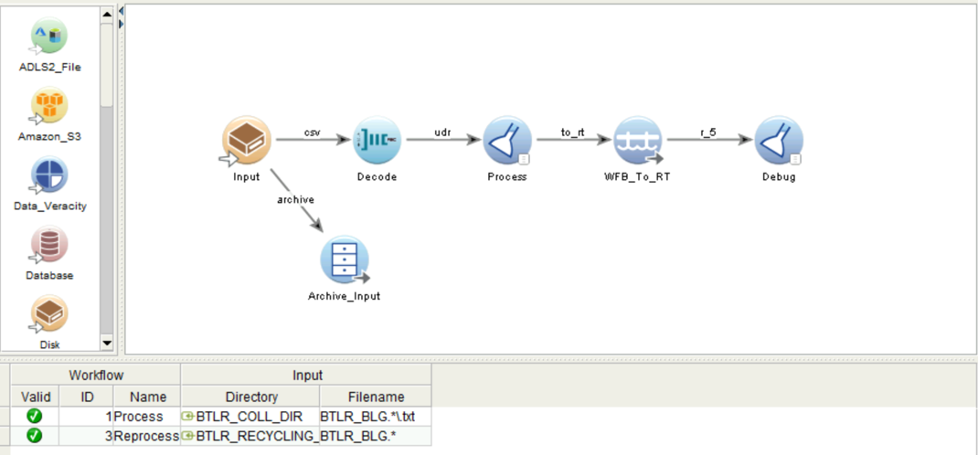

* Input(Collection Agent) :

Collects file from Directory - /naouteradatanfs/outbound and filename – BTLR_BLG.*\.txt .

* Processing:

Validates input fields:

* “payerNo”, “shipToNo” must be populated.
* blgAmtByDateARLine must not be zero,
* mngingPtnrOwnershipId must be = “9000” or “7001”.

**NOTE:** Invalid records are flagged as such and forwarded.

Sends records over a Workflow Bridge to the next step - WFL_MARSBilling_RT

1. **TCCC_MARS.WFL_MARSBilling_RT**

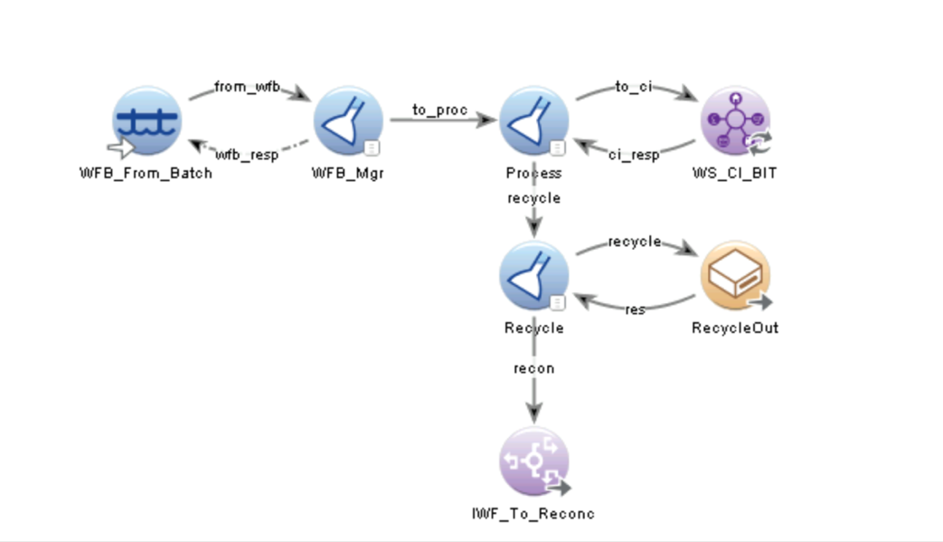

* WFB_From_Batch – Workflow Bridge collection agent

Collects records from batch workflow

* WFB_Mgr:

Sends replies to the workflow bridge (confirms records received) and forwards records for processing

* Process:
* Forwards flagged records to the ‘Recycle’ agent for logging purposes.
* Creates a Web Service request and maps the fields from the input record to the request parameters for the request; Submits Web Service requests to SAP CI for billing.

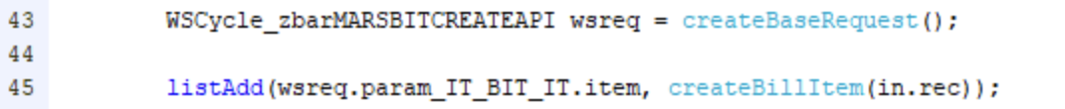

* Receives Responses from SAP CI, parses the result, and forwards failed requests for reprocessing.
* WS_CI_BIT – Web Service agent.

Calls a Web Service published by SAP CI to submit Billable Items (BITs) for billing.

The called function is ZBAR_MARS_BIT_CREATE_API.

Uses the Web Service profile PRF_WS_BottlerBilling which has been configured with a WSDL from CI.

* Recycle

Handles failed requests.

* Invalid records (field missing, etc.) are forwarded to IWF_To_Reconc for logging.
* Records that failed processing are forwarded to RecycleOut for reprocessing.
* IWF_To_Reconc Interworkflow – Forwarding agent

Sends records to be logged in the reconciliation log.

* RecycleOut – Disk Forwarding Agent

Writes records to disk to be reprocessed the following day.

1. **WFL_GenReconcReport**

* IWF_From_Proc – Interworkflow Collection Agent:

Profile: **TCCC_MARS.PRF_IWF_Reconc**

Receives reporting records from WFL_MARSBilling_RT.

* CreateReport:

Generates a file header and encodes and forwards the incoming UDRs.

1. **TCCC_MARS.WFL_GetS4Reports**

Downloads reconciliation reports from S4/CI.

1. **TCCC_MARS.WFL_MergeReports**

Merges CM and CI reports into one single report.

* Merge_Input – Merge Collection Agent

Collects from a sub folder, ‘merge’ under the collection base directory.

Merges all available files into a single stream.

* FW_Merged

Extracts the file data from the incoming Merge UDRs

* Forward

Generates a file header and encodes the incoming UDRs.

1. **TCCC_MARS.WFL_MailReports**

This could have been a task workflow, but it reads the reporting directory and calls a script,

/usr/sap/interfaces/MZP/Scripts/mailMars.sh on each found file.

After the script has been executed (and ONLY if it was successful,) the files are moved to an archive directory.